# **Infrastructure Investment and Jobs Act (IIJA)**

John Cruz; DATA 608

From the U.S Department of Transportation:

“The Infrastructure Investment and Jobs Act (IIJA) (Public Law 117-58) provides approximately $350 billion for Federal highway programs over a five-year period (fiscal years 2022 through 2026). Most of this funding is apportioned (distributed) to States based on formulas specified in Federal law. However, the Infrastructure Investment and Jobs Act also provides funding through a wide range of competitive grant programs.”

We will be focusing on two aspects of this funding related to population sizes and voting preferences.

* Is the allocation equitable based on the population of each of the States and Territories, or is bias apparent?
* Does the allocation favor the political interests (Democrat) of the Biden administration?

Table of Contents

Infrastructure Investment and Jobs Act (IIJA) 1

**Population by State** 2

**Funding Allocation by State** 3

**Is the allocation equitable based on the population of each of the States and Territories, or is bias apparent?** 4

**Does the allocation favor the political interests of the Biden administration?** 6

**Total Funding by Political Party** 7

### **Population by State**

The top 5% population sizes are California (39.4M), Texas (31.3M), and Florida (23.4M) within the U.S. states and its territories.

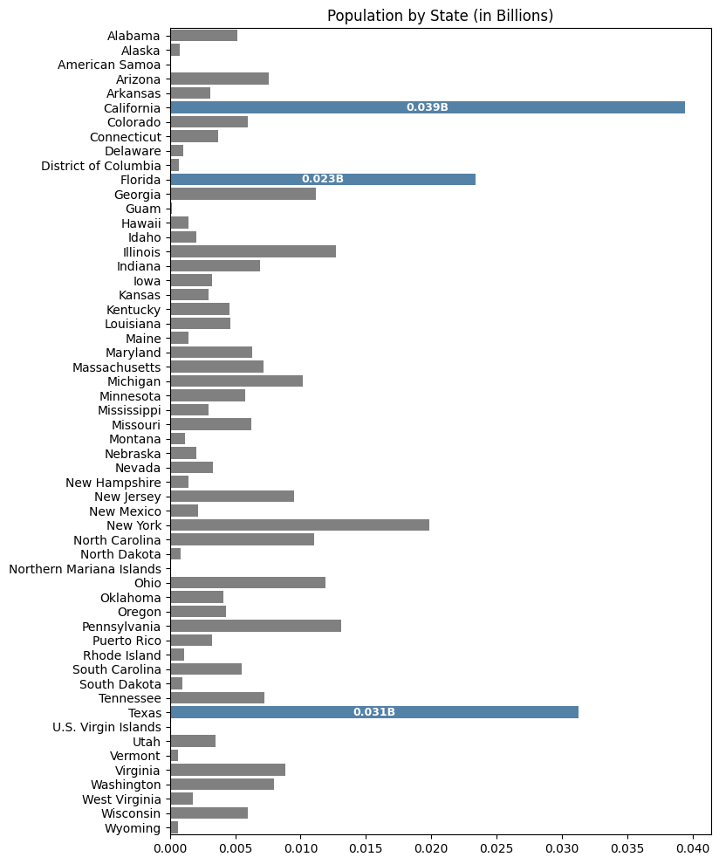

### **Funding Allocation by State**

The Top 5% within the U.S. states and territories receiving funding allocation are **California** (18.4B), **Texas** (14.2B), and **New York** ($10.1B).

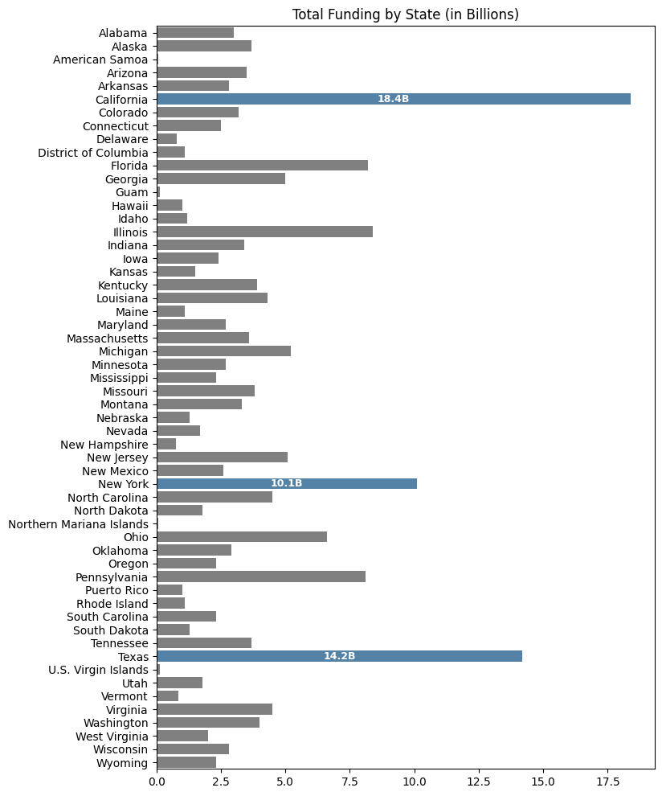

### **Is the allocation equitable based on the population of each of the States and Territories, or is bias apparent?**

We will calculate the funding ratio of dollars spent per person within a state. The formula

$$funding_ratio=\frac{total_funding}{population}$$

where total_funding and population is based by its respective state/territory.

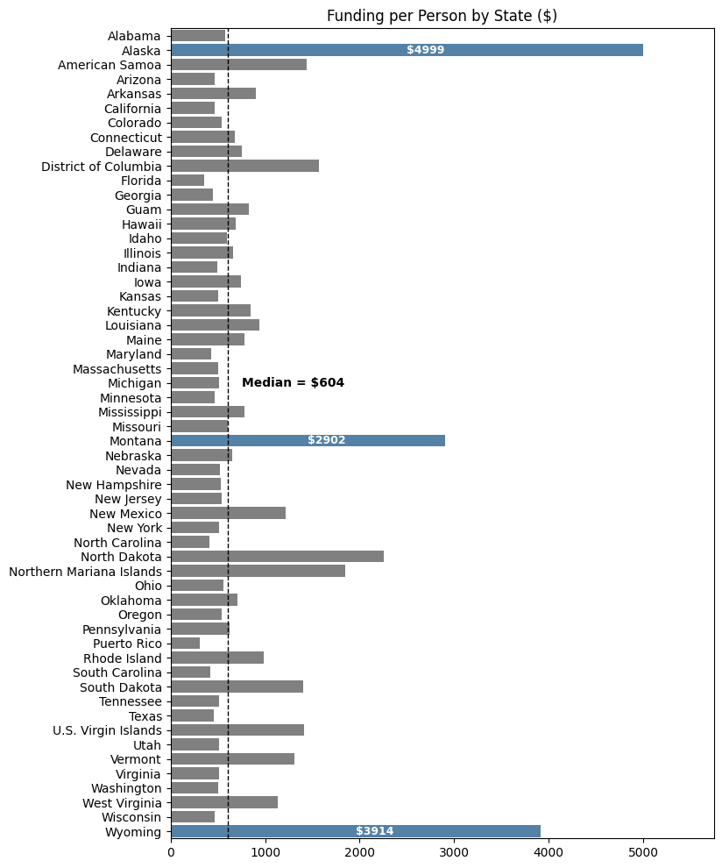

Another way to examine this is by comparing the proportion of a state's population to the proportion of funding it receives. This shows how much larger or smaller a state's funding is relative to its size. Values close to 1 indicate funding roughly proportional to population, while values significantly greater than 1 suggest the state is receiving disproportionately high funding, marking it as an outlier or exception.

When we do this, we can see that **Alaska** (9×), **Wyoming** (7×), and **Montana** (5×) receive funding that is significantly disproportionate relative to their populations.

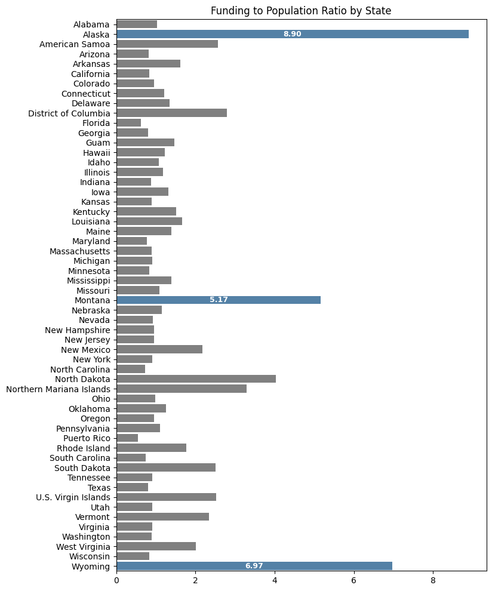

### **Does the allocation favor the political interests of the Biden administration?**

Prior to running our data, we need to remove U.S. territories that does not provide us voting counts.

**Why?** [Link](https://www.usatoday.com/story/news/politics/elections/2024/11/05/can-us-territories-vote-for-president/76072641007/)

This is because while residents of American Samoa, Guam, the Northern Mariana Islands, Puerto Rico, and the U.S. Virgin Islands are U.S. citizens (except American Samoans, who are U.S. nationals), they do not have voting representation in the Electoral College and therefore cannot vote for president in the general election.

We find that the **District of Columbia** (17×), **Vermont** (2.2×), and **Massachusetts** (2×) tend to vote more for Democrats than Republicans, indicating a strong Democratic preference relative to other states.

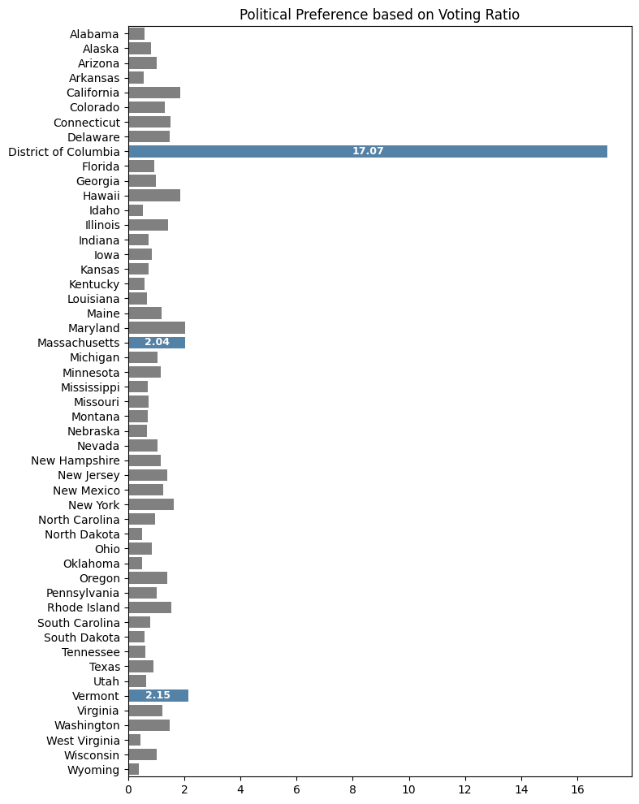

### **Total Funding by Political Party**

Using the information of which way a state/territory leans, we will categorize each state and determine the overall funding split amongst the party lines.

We find that overall, total funding is aligned with democratic leaning states that would make us believe that it does indeed support Biden's administration.

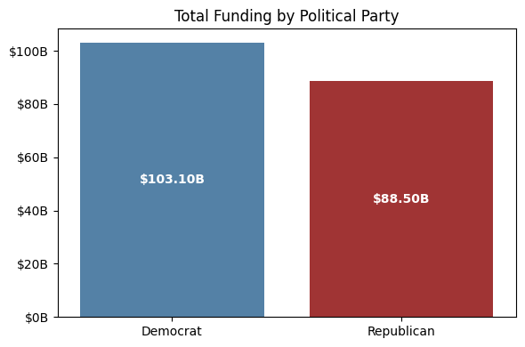

However, when we incorporate our earlier chart on funding per person by state, the disparity in funding becomes immediately apparent. The top four states receive significantly more funding, with a Democratic-leaning territory, the District of Columbia, ranking 4th. Even in 4th place, its funding ratio is closer to the median compared to Alaska.

